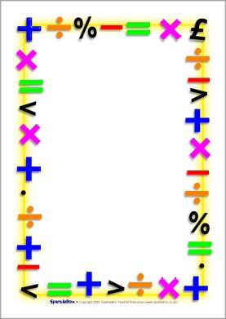

Maths Newsletter
Thank you for supporting your child’s learning through this time. Please feel free to email me at mrthurlby@oxenhope.bradford.sch.uk if you have any maths queries and I will endeavour to support you.

Other resources to use
Your child can be using Mathletics, which is a fantastic online tool, which will help support your child’s learning and will be in line with your child’s maths learning set by the teacher. Your child could also use Ttrockstars or Numbots(dependent on your child’s year group). These applications can be used on laptops or mobile devices and help to practise times tables and number bonds. If you require the login for any of these please get in touch with the class teacher and they will assist you.
Parent virtual workshops
I will be looking to run online support sessions for parents to help with home learning in Maths, if you require any assistance with a particular aspect of maths please fill in the short questionnaire below and send your response to the office.

School Calculation’s Policy
As you will be aware, your child’s class teacher has been providing wonderful daily lessons for them to complete. It is vital to your child’s learning that they are completing these lessons, this will help them to develop their understanding of the maths concepts taught through-out Oxenhope Primary school. To support with the home learning, the calculation policy will be shared on the home learning page for each of the four operations. This will show you the method we teach in school for addition, subtraction, multiplication and division.
Dear parents/ carers,
I hope you are all well and managing to keep safe. This is a quick update on Maths for home learning. – Mr Thurlby
Home learning maths parent questionnaire

- How comfortable do you feel supporting your child with maths at home?

- What aspects of maths are you most comfortable supporting your children with at home?

- What aspects of maths do you feel least comfortable supporting your child at home with?

- Would you like support in making maths more practical at home?

- Would you like to develop your own understanding of maths to help support your child, if so which areas?

- Would you like more information of the development of maths through Oxenhope primary school from reception up to year 6?

My name ________________________

My child/rens name ______________________

