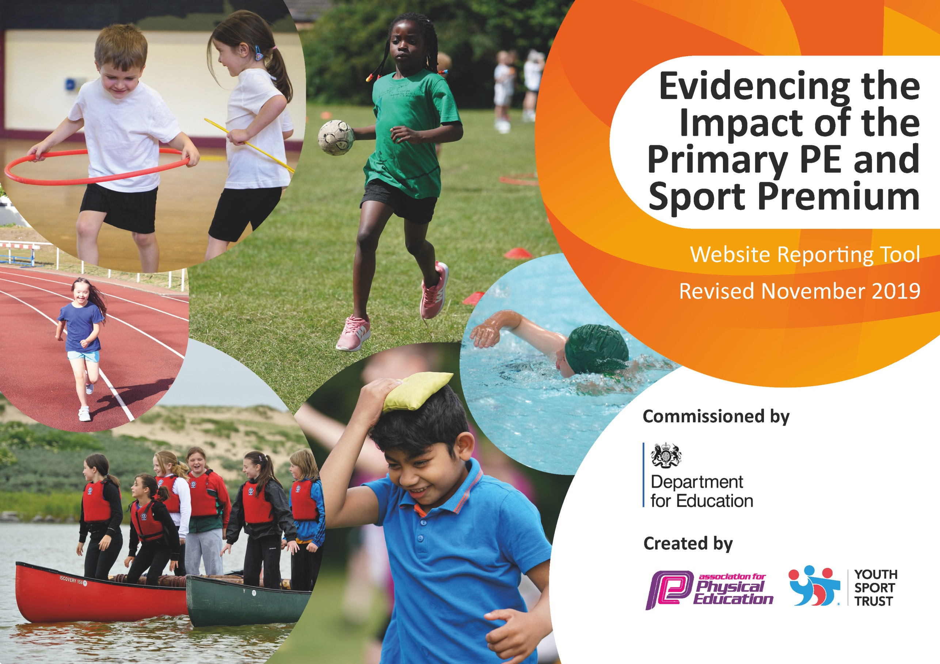
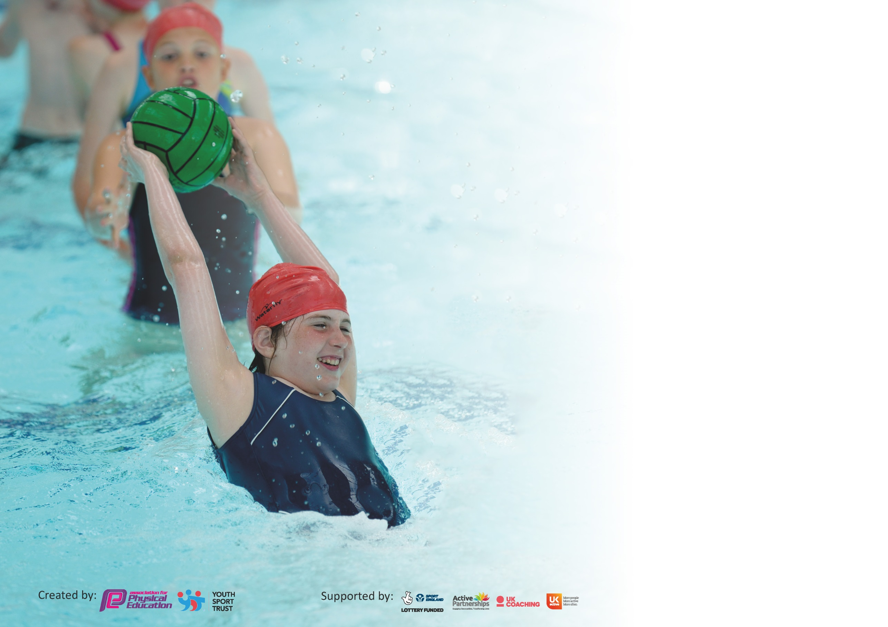

It is important that your grant is used effectively and based on school need. The Education Inspection Framework (Ofsted 2019 p64) makes clear there will be a focus on ‘whether leaders and those responsible for governors all understand their respective roles and perform these in a way that enhances the effectiveness of the school’.

Under the Quality of Education criteria (p41) inspectors consider the extent to which schools can articulate their curriculum (INTENT), construct their curriculum (IMPLEMENTATION) and demonstrate the outcomes which result (IMPACT).

To assist schools with common transferable language this template has been developed to utilise the same three headings which should make your plans easily transferable between working documents.

Schools must use the funding to make additional and sustainable improvements to the quality of Physical Education, School Sport and Physical Activity (PESSPA) they offer. This means that you should
use the Primary PE and Sport Premium to:

- Develop or add to the PESSPA activities that your school already offer
- Build capacity and capability within the school to ensure that improvements made now will benefit pupils joining the school in future years

Please visit gov.uk for the revised DfE guidance including the 5 key indicators across which schools should demonstrate an improvement. This document will help you to review your provision and to report your spend. DfE encourages schools to use this template as an effective way of meeting the reporting requirements of the Primary PE and Sport Premium.

We recommend you start by reflecting on the impact of current provision and reviewing the previous spend.

Schools are required to publish details of how they spend this funding as well as on the impact it has on pupils’ PE and sport participation and attainment by the end of the summer term or by 31st July 2020 at the latest.

We recommend regularly updating the table and publishing it on your website throughout the year. This evidences your ongoing self-evaluation of how you are using the funding to secure maximum, sustainable impact. Final copy must be posted on your website by the end of the academic year and no later than the 31st July 2020. To see an example of how to complete the table please click HERE.

Support for review and reflection - considering the 5 key indicators from DfE, what development needs are a priority for your setting and your pupils now and why? Use the space below to reflect on previous spend and key achievements and areas for development.

Key achievements to date until July 2020: | Areas for further improvement and baseline evidence of need:
Increased range of Sports Offered.  Increased range of competition participation.  Daily Mile introduced in 2017-18 and embedded between 2018-2020.  PE lessons had a Sports Subject Lead to encourage active participation for all. However, this reduced during 2020 due to bubbles and social distancing.  School Teams have new kits to increase pride.  Sports Subject lead provides a link to local clubs, provides playtime, lunchtime, after school and lesson support to develop sports participation across the school.  Introduction of play zones in playground.  Achievement more widely promoted and celebrated.  Increased access to physical activities and investment in the nature area. New Forest School focus and timetabled Forest Schools session for each class. Woodland Trust Bronze award achieved.  Silver School Games Award achieved. | Improve Year 1 access to outdoors due to missed outdoor learning experiences during lockdown.  Ensure current Year 6 are able to access national curriculum requirements for swimming as this was cancelled during lockdown.  Review of lunchtime playground system and activities available for pupils over lunchtime.  Further develop focus on Forest Schools and CPD for staff on PE. Sports Subject lead role will develop to encompass coordination of outdoor learning.  Promote and expand levels of involvement and responsibility for key staff in relation to cascading knowledge and delivering the sports and PE strategy.  Develop the new Curriculum for Physical Education and link this to the PE & Sports Strategy.  Progress with funding applications to improve nature area.  Continue to offer opportunities for pupils to represent the school competitively, ensuring that:  - a wide the range of sports is offered  - opportunities are extended more to include Key Stage One pupils.

Meeting national curriculum requirements for swimming and water safety.
What percentage of your current Year 6 cohort swim competently, confidently and proficiently over a distance of at least 25 metres? N.B. Even though your pupils may swim in another year please report on their attainment on leaving primary school at the end of the summer term 2020. | Unfortunately swimming lessons were cancelled during lockdown.
What percentage of your current Year 6 cohort use a range of strokes effectively [for example, front crawl, backstroke and breaststroke]? | See above.
What percentage of your current Year 6 cohort perform safe self-rescue in different water-based situations? | See above.
Schools can choose to use the Primary PE and Sport Premium to provide additional provision for swimming but this must be for activity over and above the national curriculum requirements. Have you used it in this way? | No

Action Plan and Budget Tracking
Capture your intended annual spend against the 5 key indicators. Clarify the success criteria and evidence of impact that you intend to measure to evaluate for pupils today and for the future.

Academic Year: 2019/20  Key indicator 1: The engagement of all pupils in regular physical activity – Chief Medical Officer guidelines recommend that primary school children undertake at least 30 minutes of physical activity a day in school | Total fund allocated: £17,580 |  |  | Date Updated:1.9.2020
Key indicator 1: The engagement of all pupils in regular physical activity – Chief Medical Officer guidelines recommend that primary school children undertake at least 30 minutes of physical activity a day in school |  |  |  |  |  |  | Percentage of total allocation:
 |  |  |  |  |  |  | 45%
School focus with clarity on intended impact on pupils: | Actions to achieve: |  |  | Funding allocated: | Evidence and impact: |  | Sustainability and suggested next steps:
To increase the opportunities for children to engage in structured exercise during each day.  Key indicator 2: The profile of PE and sport being raised across the school as a tool for whole school improvement | Daily mile embedded for all children in school. Sports Subject Leads supports in PE lessons to ensure all children are active participants.  Lunchtime and Playtime sports and games introduced and co-ordinated by the Sports Subject Lead in line with competition calendar and children’s interests. |  |  | Sports Subject leader & admin time £8,000 | Participation numbers in sports open to all (Cross Country) Numbers of children wanting to play in a school team. Uptake in numbers of school clubs.  Participation at lunchtimes of children monitored. |  | Identify children that have not accessed the opportunities and put in place a plan for those less active children or reluctant participators.  Ensure all staff are kept up to date with monitoring and plans for individuals or groups of children.  This will be more sustainable once social distancing restrictions have eased.
Key indicator 2: The profile of PESSPA being raised across the school as a tool for whole school improvement |  |  |  |  |  |  | Percentage of total allocation:
 |  |  |  |  |  |  | 17%
School focus with clarity on intended impact on pupils: | Actions to achieve: |  |  | Funding allocated: | Evidence and impact: |  | Sustainability and suggested next steps:
Pupils able to identify as sporting and want to take part in school and inter school competitions of an increasing range of sports. | House competitions run within classes & on Sports Day.  School Teams have trial sessions & link to school clubs. Children see results on the Board, via Twitter, Newsletters to parents and in the local newspaper. Assemblies celebrating sporting achievement and end of year sporting awards. |  |  | Sports Subject leader & admin time £3,000 | Children interviews regarding attitudes to sport.  Environment check. Media and school news monitoring for sporting event celebration. |  | Ensure staff kept up to date with monitoring & plans for individuals/groups of children. Improve delivery of strategy by widening responsibility for leadership of PE and Sports. Sports Subject Leader & Headteacher to cascade information and engage other staff in the evolving Sports strategy and Curriculum.
Key indicator 3: Increased confidence, knowledge and skills of all staff in teaching PE and sport |  |  |  |  |  |  | Percentage of total allocation:
 |  |  |  |  |  |  | 6%
School focus with clarity on intended  impact on pupils: |  | Actions to achieve: | Funding  allocated: |  |  | Evidence and impact: | Sustainability and suggested  next steps:
Specialist teachers to support staff  CPD in a rolling programme of areas. |  | Gymnastics coach to support teaching of gymnastics (last year dance teacher to support dance) | £1,080 |  |  | Quality of Gymnastics increases over time. | Enable opportunities for staff to observe & discuss techniques with any visiting sports coaches or instructors.  Continue to meet with staff on a regular basis to discuss the benefits of the various initiatives and identify any further children who could benefit.  Enable more opportunities for staff with key skills and experience related to Sports & PE increased opportunity for involvement in the strategy evolution and delivery and for cascading their specific areas of knowledge.

Key indicator 4: Broader experience of a range of sports and activities offered to all pupils |  |  |  | Percentage of total allocation:
 |  |  |  | 17%
School focus with clarity on intended  impact on pupils: | Actions to achieve: | Funding  allocated: | Evidence and impact: | Sustainability and suggested  next steps:
Maintaining and increasing the range of sports via clubs and competition links.  Key indicator 5: Increased participation in competitive sport. | Maintain the new sports (to school) introduced over last 2 years – cricket, hockey, boccia and introduce new – netball. | Sports Subject leader & admin time £3,000 | Curriculum, clubs and competition calendar reflect an increasing range of sports. | Continue with this focus and provision and also Invest in resources which encourage physical activity for Early Years pupils, eg invest in EY outdoor area and resources.
Key indicator 5: Increased participation in competitive sport |  |  |  | Percentage of total allocation:
 |  |  |  | 14%
School focus with clarity on intended  impact on pupils: | Actions to achieve: | Funding  allocated: | Evidence and impact: | Sustainability and suggested  next steps:
More children represent the school in a wider range of sports. | Increase the competitive opportunities for all children by developing the clubs and lunchtime sports alongside the competition calendar. | Sports Subject leader & admin time £2,500 | As above, Curriculum, clubs and competition calendar reflect an increasing range of sports. | Continue with this focus and provision and additionally work on developing links/shared activities with local schools or schools within the Trust.  Hopefully we can progress further with this when social distancing restrictions improve.

Signed off by
Head Teacher:
Date:
Subject Leader:
Date:
Governor:
Date:

