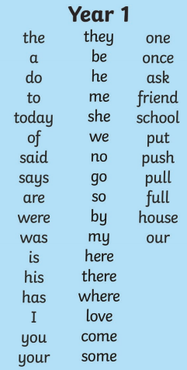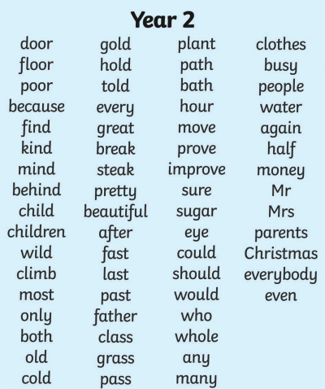
Spelling
Above are the spellings you will need to know by the end of the year. Please practice them as often as you can. I will choose 5 of these spellings and 5 of the spelling pattern words we have been learning in class. We will be revising our Year 1 words to make sure they’re embedded. The spelling test will take place on a Wednesday morning
Maths
The log in for Mathletics and TT rockstars will be given over the next few weeks
Topic
You can do as little or as much topic homework as you like. It is recommended that you do at least 1 creative piece, linked with the topic, per half term. As this half term topic is all about local village life with a focus on mills and factories you could do some weaving, create a model with moving parts, build a giant mill, visit Salts Mill and draw it, draw a map of the village of Oxenhope and plot all the mills and factories etc. I can’t wait to see your wonderful creations! Super homework will be displayed on a homework board outside the classroom.
Reading
Please read with your child for 15 minutes every night and discuss what you have read.

